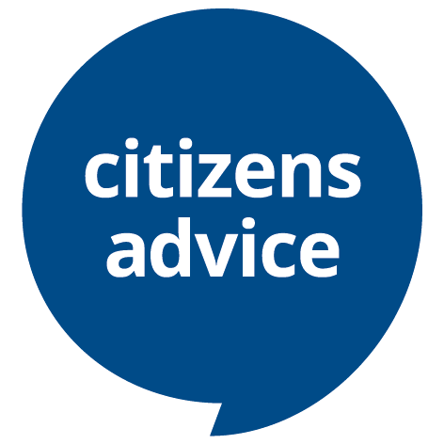
Volunteer diversity monitoring information

Background
Citizens Advice values diversity, promotes equality, and challenges discrimination. We welcome and encourage volunteer applications from people of all backgrounds, age, disability, gender, gender identity, marriage and civil partnership, pregnancy and maternity, race, religion or belief, sexual orientation.
Monitoring recruitment and selection procedures is one way that helps us to ensure that there is no discrimination in the recruitment process. To do this we need to know about the diversity profile of people who apply for volunteer roles at Citizens Advice Hull & East Riding.

General Data Protection Regulations

Under data protection law we are allowed to ask for this information as it's sole purpose is to allow us to monitor the diversity of our applicants. The information you give us will be kept securely, is confidential and will be used for monitoring our equality policies only. It will not be seen by anyone responsible for making recruitment decisions. If you would prefer not to answer any of the questions we ask, please leave them blank.
Note on accessibility: If you are using keyboard only and need to put a cross in the relevant box, you should be able to arrow across, and type in the box. If this is not possible put a cross next to the relevant box. If you need this form in another format please contact Citizens Advice Hull & East Riding.
Diversity Monitoring Form
Applicant ref. number
(local Citizens Advice use only):
Which volunteer role are you applying for?

Age
Which age bracket do you fit into? Put a cross in the relevant box.

Under 25
25 - 34
35 - 44
45 - 54
55 - 64
65 and over

Gender
What best describes your gender? Put a cross in the relevant box or write in a preferred term.
Female
Male
I prefer to use another term

Please write in……………………………………...

Sexual orientation
What is your sexual orientation? Put a cross in the relevant box or write in a preferred term.
Heterosexual/Straight
Gay Man
Gay Woman/Lesbian
Bisexual
I prefer to use another term

Please write in……………………………………….

Ethnic origin
How would you describe yourself? Choose one section (A to E) and put a cross in the relevant box within it.

A. White | English/Welsh/Scottish/Northern Irish/British
 | Irish
 | Gypsy or Irish Traveller
Any other White background

Please write in……………………………………….
B. Mixed/multiple ethnic groups | White & Black Caribbean
 | White & Black African
 | White & Asian
Any other Mixed/multiple ethnic background

Please write in……………………………………….
C. Asian/Asian British | Indian
 | Pakistani
 | Bangladeshi
 | Chinese
Any other Asian Background

Please write in……………………………………….
D. Black/African/ Caribbean /Black British | African
 | Caribbean
Other Black/African/Caribbean background

Please write in……………………………………….
E. Other ethnic group | Arab
Any other ethnic group

Please write in……………………………………….

Disability
Do you consider yourself to be a disabled person or do you have a long-term physical or mental health condition? Put a cross in the relevant box.
Yes
No

NB. The information on this form is for monitoring purposes only. We follow the social model of disability which believes that it is the barriers created by society which disable people. If you require any additional support or equipment in relation to the recruitment process or that would enable you to carry out the volunteer role, please tell us on the application form or during the interview.
Gender Identity
Is your gender identity the same as the gender you were assigned at birth? Put a cross in the relevant box.

Yes
No

Religion or belief
Which group below do you most identify with? Put a cross in the relevant box.
No religion
Christian (including all denominations)
Buddhist
Hindu
Jewish
Muslim
Sikh
Any other religion or belief

Please write in……………………………………….

How did you hear about this volunteering opportunity?
Please give details below:

