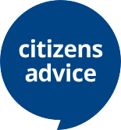
What does Citizens Advice Hull & East Riding do?

We’re here to help. Whoever you are.
Whatever the problem.

Citizens Advice Hull & East Riding

How we can help
We provide free, confidential and independent advice to help people overcome their problems. We are a voice for clients and consumers on the issues that matter to them, we campaign on big issues. We value diversity, champion equality and challenge discrimination and harassment. We are here for everyone.

Our staff are trained to advise on many issues, including:
- welfare benefits | - neighbourhood disputes
- housing | - education and healthcare
- employment | - money and credit problems
- consumer rights | - immigration and residency queries
- human rights | - family and personal issues

We arm you with all the facts and possible outcomes of different options. That way you can make the decision that’s right for you. If needed, we can also offer practical support such as help with filling forms, writing letters, negotiating with third parties, or acting on your behalf.

Ways to get advice
- over the telephone | - via email
- face to face | - online via citizensadvice.org.uk

Specialist Services
- Money and Debt Advice | - Armed Forces Money Advice
- Connect Well | - Pension Guidance
- Help Through Crisis | - Building Better Opportunities
- Universal Support help to claim
- Community Connect

Languages
If English is not your first language, we have access to translation services.

Free, confidential advice. Whoever you are.

Our dedicated staff and volunteers
Volunteers support the delivery of our work alongside paid staff. Our volunteers come from all sorts of backgrounds and help with everything we do: IT, administration, campaigning, giving advice.

Our volunteers benefit from the experience too – for example all our retired volunteers believe volunteering keeps them mentally active, and nine in ten unemployed volunteers believe it helps them to move into employment or education.

We share one goal
Volunteer, employee or supporter, we all believe in the same thing; a fair society for all, free from the effects of poverty and injustice.

We help people, families and communities by providing advice that helps people overcome their problems and campaigning to ensure that people’s voices are heard

Interested in volunteering?
If you would like to find out more information, please contact volunteering@hull-eastridingcab.org.uk

Interested in making a donation?
We are a local charity and rely on grants and donations to continue our work. If you would like to make a donation please call us on 01482 328990.

Accessing advice
Telephone : 0800 144 8848 (free phone). Mo – Fri 9.am – 5.pm
E-mail Address: e-advice@hull-eastridingcab.org.uk

Our drop in advice service is located in Hull, Bridlington, Beverley and Goole, Monday to Friday.

Outreach Sessions

Pre Covid-19 we operated advice appointments from 36 community venues. These services are temporarily suspended.

Our social return on investment for 2019/20 demonstrates the value of our service. For every £1 spent on the Citizens Advice Hull and East Riding service in 2019/20:

- We benefit our clients by £19.30
- We save government and public services at least £3.21 and
- A minimum estimate of our social and economic value to society is £23.12.

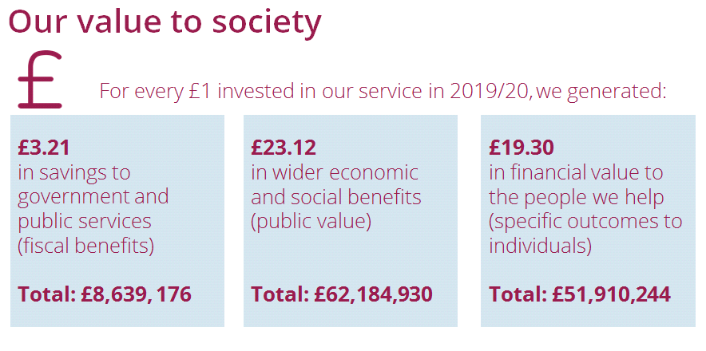

Hull & East Riding Citizens Advice Bureau – Private Company Limited by Guarantee – Registered Number 5141612 England
Registered Office: The Wilson Centre, Alfred Gelder Street – HU1 2AG – Registered Charity Number 1106453,
Authorised and regulated by the Financial Conduct Authority FRN: 617637
• Beverley office: - 100 Lairgate – HU17 8JQ • Bridlington office: - 5a Prospect Arcade – YO15 2AL
• Goole Office: - 80 Pasture Road – DN15 6HD, • Hull Office: - The Wilson Centre, Alfred Gelder Street, HU1 2AG
November 2020
Hull & East Riding Citizens Advice Bureau – Private Company Limited by Guarantee – Registered Number 5141612 England
Registered Office: The Wilson Centre, Alfred Gelder Street – HU1 2AG – Registered Charity Number 1106453,
Authorised and regulated by the Financial Conduct Authority FRN: 617637
• Beverley office: - 100 Lairgate – HU17 8JQ • Bridlington office: - 5a Prospect Arcade – YO15 2AL
• Goole Office: - 80 Pasture Road – DN15 6HD, • Hull Office: - The Wilson Centre, Alfred Gelder Street, HU1 2AG

